InterContinental Sofia – Europe Hotel of the Year at the IHG Star Awards 2019!
October 30, 2020, Sofia, Bulgaria. Exciting news for InterContinental Sofia despite the global challenges the hotel industry is facing! The leading five-star hotel in Bulgaria and the first representative of the InterContinental® Hotels & Resorts brand in the country, has been awarded “Hotel of the Year 2019” at the IHG® Europe Star Awards. This award is given to the best performing hotel in serving guests, hotel owners, colleagues and the community, and is a mark of successful management and delivery of best practices in hospitality.
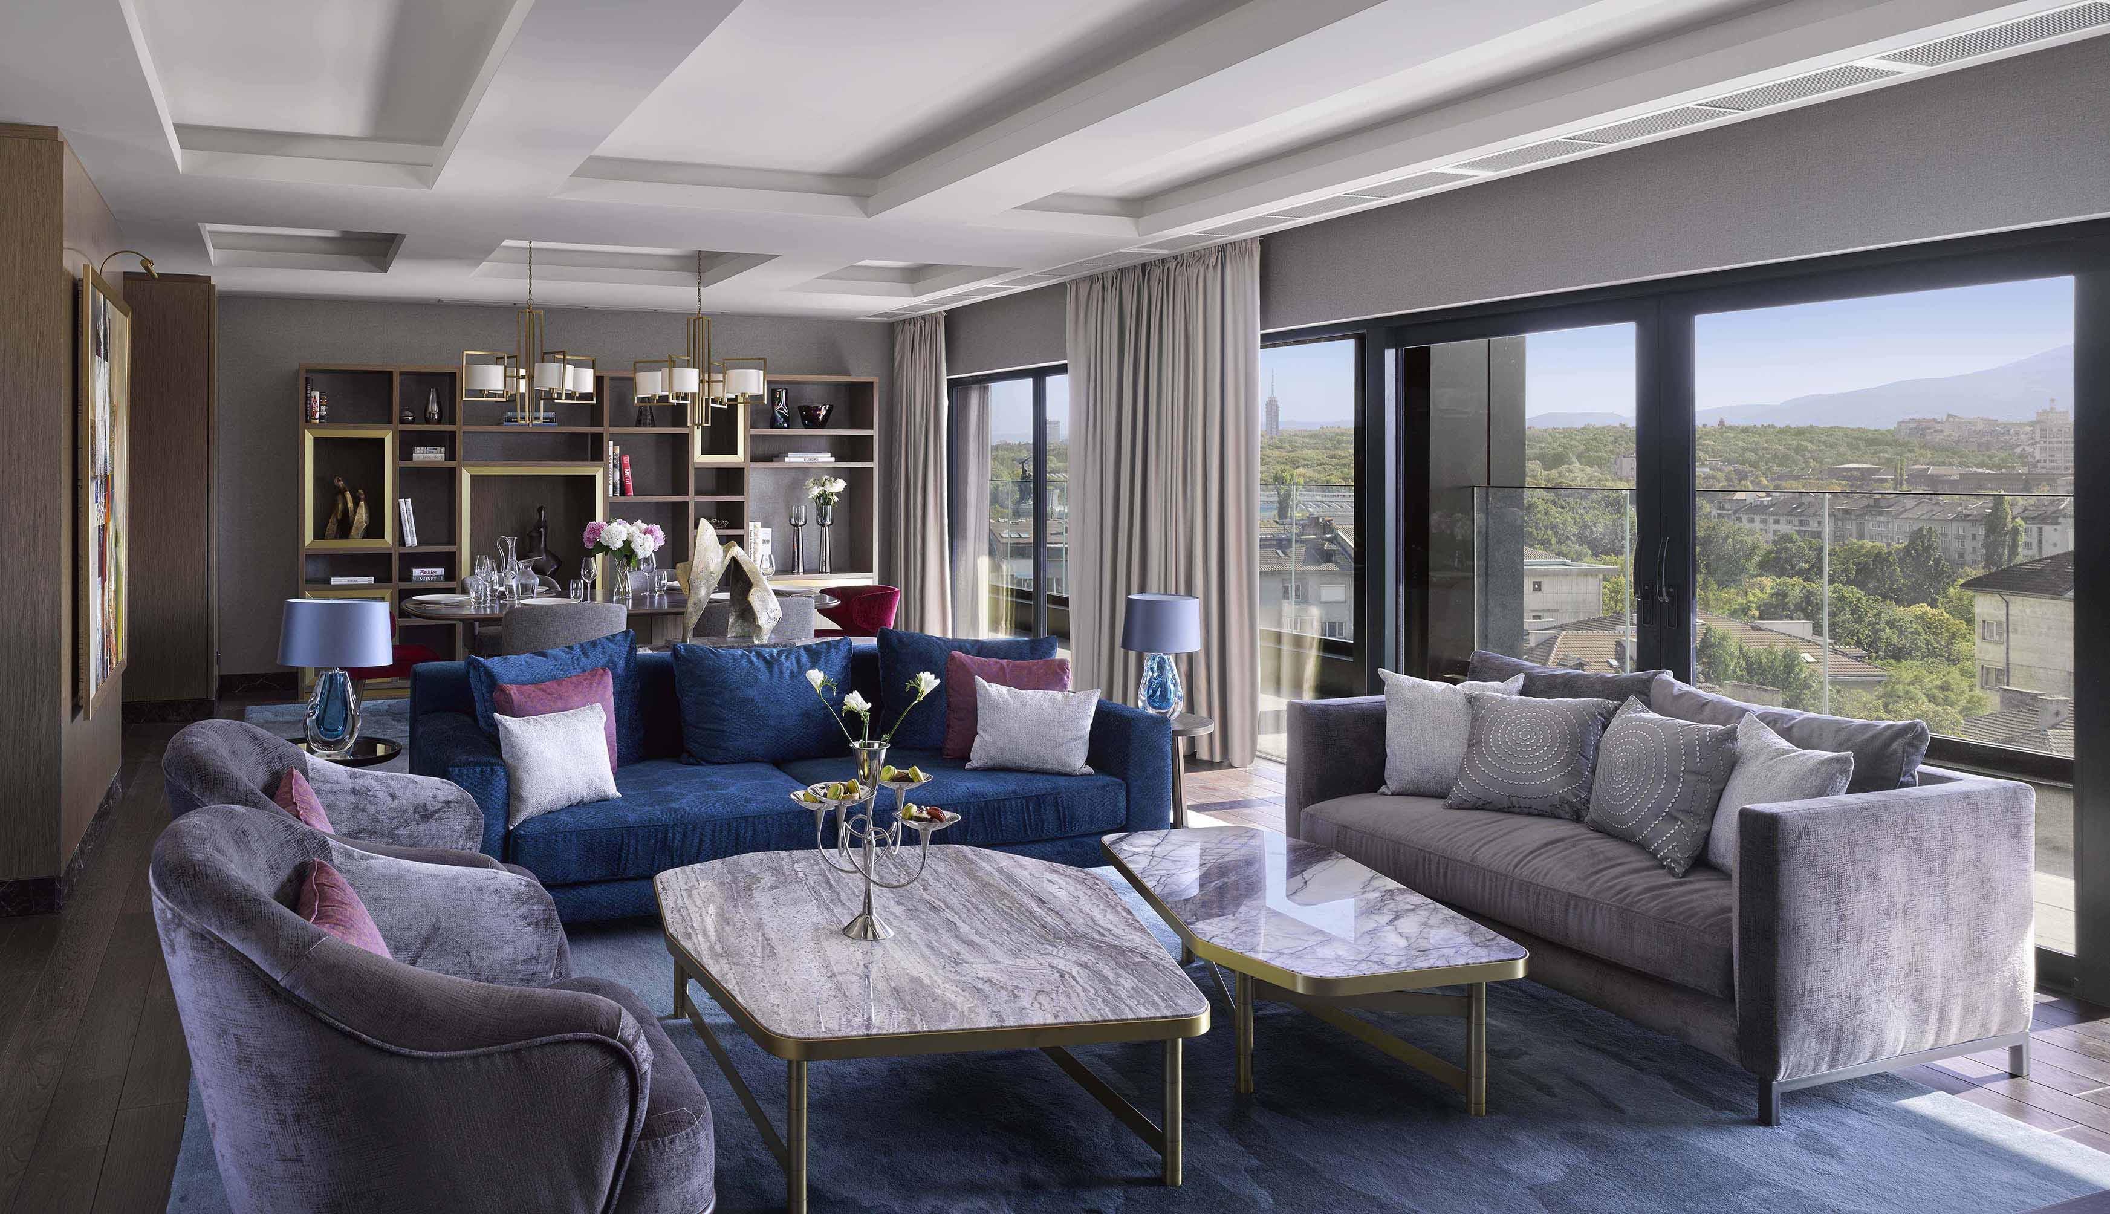
Presidential Suite, InterContinental Sofia
In addition, InterContinental® Sofia, has received two other prizes at the prestigious awards for the hotel chain – “Heartbeat Torchbearer” and “Trailblazer”. Torchbearers are hotels which have demonstrated high levels of service when delivering true hospitality for everyone and Trailblazers are those which achieved all performance metrics, including financial, service quality, colleague satisfaction and sustainability indicators. “All these awards are an evidence of the hard work of the whole team of InterContinental Sofia and I cannot be more proud of the amazing results we have achieved together!” – shares the General Manager, Angelo Zuccala. In our industry it is very important to stay strong and support each other and these awards show that team work and positive attitude always lead to success.” – adds Mr. Zuccala.

Apart from the prizes at the IHG Star Awards, since the beginning of 2020 InterContinental Sofia has been leading the ranking for overall guest satisfaction among all InterContinental® hotels in Europe.
About InterContinental Sofia:
InterContinental Sofia is part of InterContinental Hotels Group (IHG®), a leading company in the hotel industry with more than 400,000 employees in over 100 countries. Currently IHG® has 5,977 hotels in operation and 1899 under construction worldwide. Located in the heart of the Bulgarian capital – Sofia, the hotel offers breath-taking views to St. Alexander Nevski Cathedral and Vitosha mountain, unforgettable culinary experience at Floret Restaurant and Bar and a truly luxury InterContinental® service. InterContinental Sofia is following uncompromised cleaning procedures and has implemented the IHG Clean Promise and IHG Meet with Confidence programs in order to ensure the health and safety of its guests and colleagues.

